A picture containing clipart

Description generated with very high confidence

Azure 103 Module 4

Hands On - 14

Azure Certification Training

[**support@intellipaat.com**](mailto:support@intellipaat.com)

**+91-7022374614**

**US: 1-800-216-8930(Toll Free)**

**Azure 103 Module 4 , Hands On – 14**

**Attach NSG to a subnet**

**Step 1:** Open network security group and click on ‘Subnets’.

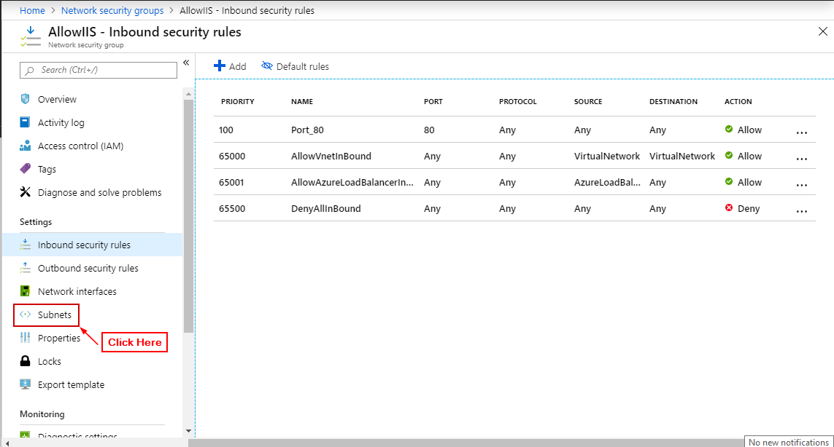

**Step 2:** Click on ‘+ Associate’.

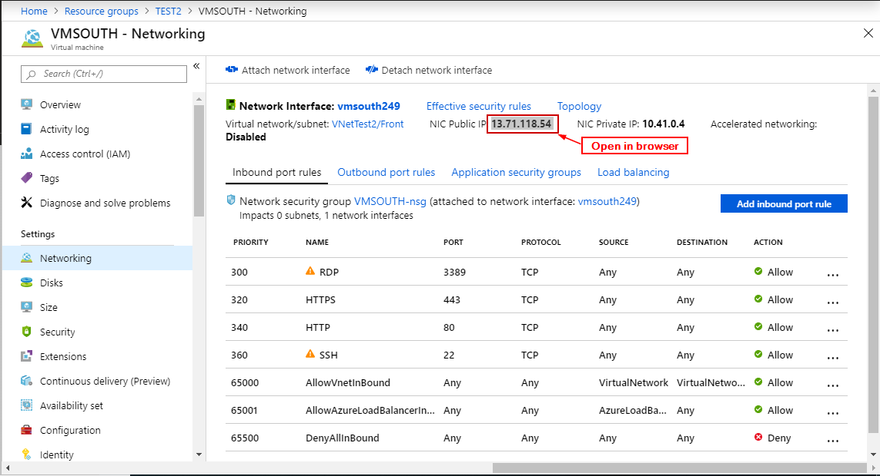

**Step 3:** Select a Virtual Network and subnet and click ‘OK’.

